AKHILA KATAKAM

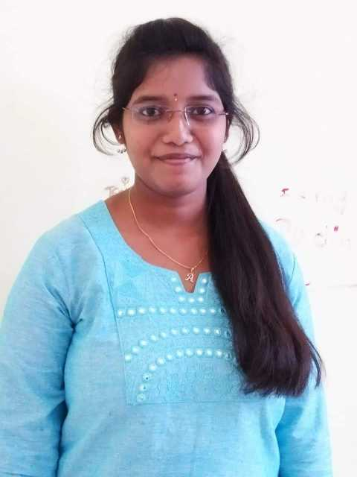

Contact: 9491431218

E-mail: [akhilakatakam956@gmail.com](mailto:akhilakatakam956@gmail.com)

In :Akhila katakam

**CAREER OBJECTIVE:**

To work in a professional manner where I can utilize my knowledge, skills and to develop myself along with the improvement of organization.

**ACADEMIC QUALIFICATION:**

|  |  |  |  |  |
| --- | --- | --- | --- | --- |
| **Course** | **Institutions** | **Board/**  **University** | **Year of**  **Completion** | **Percentage** |
| B. Tech  (ECE) | Siddartha Institute of Science and Technology | JNTUA | 2021 | 80.4 % |
| Intermediate | Sri chaitanya Junior College, Tirupati | Board of  Intermediate  Education | 2017 | 95.6 % |
| SSC | Zuari cement‘s D.A.V model school | Board of  Secondary Education | 2015 | 9.3 CGPA |

**PROGRAMMING SKILLS:**

* MS office
* C Language
* PYTHON

**WORKSHOPS ATTENDED:**

* Attended a workshop at SRI VIDHYANIKETHAN COLLEGE.
* Attended workshop based on IOT.

**AWARDS AND ACHIEVEMENTS:**

* I won **THIRD PRIZE** in Poster Presentation at **SRI VIDYANEKETHAN COLLEGE** for **BRAIN COMPUTER INTERFACE**.
* I won many prizes at school for extra curricular activies.

**AREA OF INTERESTS:**

Workshops

Innovative clubs

Participating in social activities

**STRENGTHS:**

* Good team player
* Self-motivated
* Hard working nature

**PERSONAL DETAILS:**

* Name : KATAKAM AKHILA
* Father Name : K SUBRAMANAYAM
* Date of Birth : 28-01-2000.
* Nationality : Indian.
* Hobbies : Reading books, Listening music

Playing games.

* Languages known : English, Telugu and Hindi.
* Address : 1-1-50A Main bazar, Yerraguntla, Kadapa

Andhra Pradesh, 516309.

**DECLARATION:**

I, K. Akhila do here by conform that the information given above is true to the best of my knowledge.

**Date :**

**Place :**

**(K. Akhila)**